DAC-01-2581_PRS2023_ITS

**SEPULUH NOPEMBER INSTITUTE OF TECHNOLOGY**

**DAC-01-2581**

**DAC 2023**

**DAC 2023**

**DAC 2023**

**DAC 2023**

**\*please change the yellow highlights according to your analysis results**

**CHAPTER I: Introduction**

Lorem ipsum dolor sit amet, consectetur adipiscing elit. Nullam eget urna nec arcu interdum ullamcorper. Sed rhoncus sapien at justo vehicula, id interdum nisi ullamcorper. Quisque non tellus in neque vulputate dictum sit amet id justo. Sed et volutpat ipsum. Sed vel nunc eu metus blandit dictum. Vestibulum ut tincidunt ligula, in facilisis tortor.

**CHAPTER II: Theoretical Framework**

A. Linear Regression (Font 12)

(Font 12) Proin ut consequat ligula. Morbi vestibulum, dui id efficitur dignissim, est libero tincidunt quam, non gravida quam ligula a tellus. Vivamus fermentum efficitur tortor, id condimentum dolor scelerisque et [1]. Xiao and Jennings Sed tristique, arcu a bibendum lacinia, urna sapien iaculis libero, ut venenatis ligula purus id massa [2]. Nulla sit amet tellus eget dui interdum lacinia in a leo Lorem ipsum dolor sit amet, consectetur adipiscing elit which has the following form

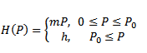

(2.1)

Compartment diagram of the model can be shown in figure 1 and the the meaning of the symbols are given in Table 2.1

**Table 2.1.** Meaning of the symbols

|  |  |
| --- | --- |
|  | Number of Prey at time t |
|  | Number of Predator at time t |
|  | Growth rate of Prey |
| *a* | decrements of prey |
| K | Carrying capacity of Prey |

**CHAPTER III: Analytical Steps**

Lorem ipsum dolor sit amet, consectetur adipiscing elit. Nullam eget urna nec arcu interdum ullamcorper. Sed rhoncus sapien at justo vehicula, id interdum nisi ullamcorper. Quisque non tellus in neque vulputate dictum sit amet id justo. Sed et volutpat ipsum. Sed vel nunc eu metus blandit dictum. Vestibulum ut tincidunt ligula, in facilisis tortor.

**CHAPTER IV: Analysis of Results**

(font 12) Lorem ipsum dolor sit amet, consectetur adipiscing elit. Nullam eget urna nec arcu interdum ullamcorper [3]. Sed rhoncus sapien at justo vehicula, id interdum nisi ullamcorper. Quisque non tellus in neque vulputate dictum sit amet id justo. Sed et volutpat ipsum. Sed vel nunc eu metus blandit dictum. Vestibulum ut tincidunt ligula, in facilisis tortor [4]. Suspendisse ultricies semper justo, eget ultrices dolor pellentesque nec. In hac habitasse platea dictumst. Nullam vel magna urna. Sed tristique, arcu a bibendum lacinia, urna sapien iaculis libero, ut venenatis ligula purus id massa.. These results can serve as a reference to determine in the clustering which provinces have high and low stunting rates.

**(Font 12) Figure 4.1.** Barchart diagram

Nullam eget urna nec arcu interdum ullamcorper. Sed rhoncus sapien at justo vehicula, id interdum nisi ullamcorper. Quisque non tellus in neque vulputate dictum sit amet id justo. Sed et volutpat ipsum. Sed vel nunc eu metus blandit dictum.

Based on **Attachment 1,** it can be observed for provinces from the highest to the lowest average stunting rates. These results can serve as a reference to determine in the clustering which provinces have high and low stunting rates.

**CHAPTER V : Conclusion and Recommendation**

(Font 12) The conclusion should be concise and clear

# REFERENCES

(IEEE Style, Times New Roman, Font 12)

|  |  |
| --- | --- |
| [1] | J. L. Rosenberg och L. M. Epstein, Schaum's Outline of College, New York: McGRAW - HILL, INC, 2000. |
| [2] | R. Chang och J. Overby, General Chemistry; The Essential Concepts, New York: Mc-Graw Hill, 2011. |
| [3] | N. D. Jespersen, J. E. Brady och A. Hyslop, Chemistry: The Moleculare Nature of Matter, Hoboken: John Wiley & Sons, Inc, 2012. |
| [4] | L. J. Malone och T. Dolter, Basic Concepts of Chemistry, New York: John Wiley & Sons, Inc, 2010. |

**ATTACHMENT**

Attachment 1: Stunting Rate Diagram

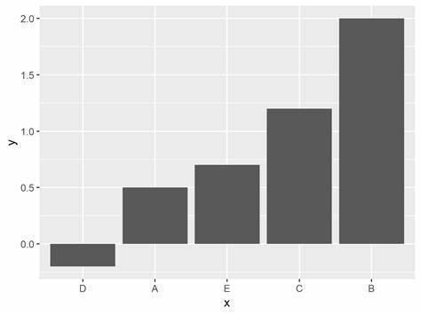

Attachment 2:

**SYNTAX**